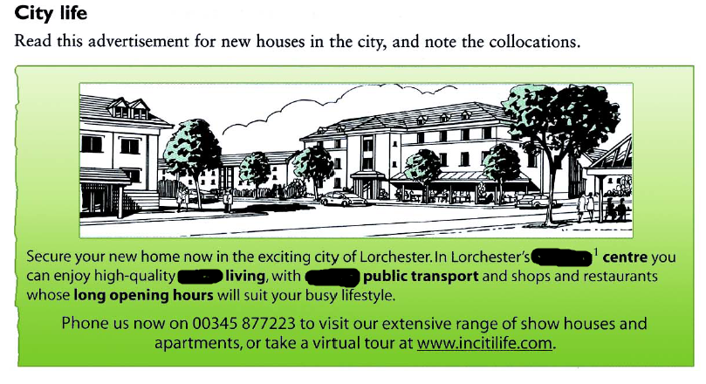

urban, bustling, dependable

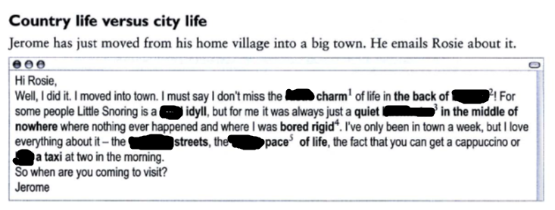

congested, rustic, beyond, rural , hectic, hail , backwater,

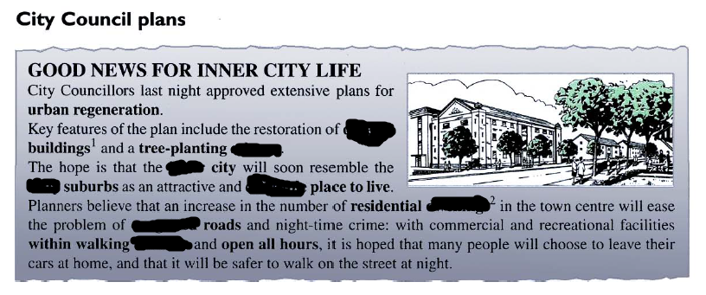

, inner, derelict, leafy, impassable, proximity, dwellings, desirable , scheme

My city is **fraught with**………………………..

Due to polution in the city it is impossible to **make out**

Our city is **thriving** as a consequence of

The city centre is **lined up with**